# Sprint 1 Plan - Planetarium

Scrumbags

## Sprint Completion 10/24/2023, Revision 2, 10/23/2023

# Goal

Create the basic and foundational functionality and UI for the application. Establish infrastructure and get familiar with Flutter and Firebase.

# Task Listing

Check [here](https://plannertarium.atlassian.net/jira/software/projects/PLANNER/boards/1) for the most up to date view.

As a user, I want to be able to…:

1. see my inputted information when I reopen the app so that I do not need to keep it open - 11h
   1. Create a Firestore Database - 1h
   2. Add proper rules to the database - 1h
   3. Add user authentication to track user accounts - 2h
   4. Create a data format for tasks in the database - 1h
   5. Create a class in Dart to represent tasks - 1h
   6. Create a data format for events in the database - 1h
   7. Create a class in Dart to represent events - 1h
   8. Create basic unit tests for the database - 2h
   9. Create methods to read user data from the database into memory upon app launch - 1h
2. create tasks so that I can see what my tasks are - 9h
   1. Create a new Widget on the UI to accept new tasks - 2h
   2. Display tasks in daily view - 2h
   3. Display tasks in weekly view - 2h
   4. Display tasks in monthly view - 2h
   5. Create methods that save a task object to the database - 1h
   6. Link the UI Widget to the new method - 0h
3. change properties of a task so that I can mark them as completed, move to another date, etc - 7h
   1. Add UI for swipe left on a task Widget - 1h
   2. Add UI for swipe right on a task Widget - 1h
   3. Add UI for double tap on a task Widget - 1h
   4. Add UI for holding down on a task Widget - 1h
   5. Add UI for moving tasks to different times on the timeline - 2h
   6. Add getters and setters to Task class to update their attributes - 1h
4. create events so that I can see what my events are - 9h
   1. Create a new Widget on the UI to create new events - 2h
   2. Display events in daily view - 2h
   3. Display events in weekly view - 2h
   4. Display events in monthly view - 2h
   5. Create methods that save an event object to the database - 1h
   6. Link the UI Widget to the new method - 0h
5. change properties of an event so that I can give them details about location/time/etc - 4h
   1. Add UI for moving events to different times on the timeline - 3h
   2. Add getters and setters to Event class to update their attributes - 1h
6. switch between time windows so that I can plan for the short, medium and long term as needed - 7h
   1. build the screen for the daily view - 1h
   2. build the screen for the weekly view - 1h
   3. build the screen for the monthly view - 1h
   4. add UI buttons and swipes at the top - 2h
   5. implement buttons that change the current view - 2h
7. view of the current event so I can quickly see and take note of what is happening - 7h
   1. Add check to see if the current time overlaps with an event - 0h
   2. Create a new UI Widget to indicate an event that is currently happening - 2h
   3. Link the check to the Widget - 0h
   4. Add a progress bar to the new widget - 2h
   5. Implement a button making the widget take you to the event view - 1h
   6. Add a progress bar to the event view UI - 2h
8. User story [added mid sprint]

# Team Roles

Steven Xue - Backend developer

Liam Xu - Frontend developer

Andrew Hu - frontend developer, backend developer

Andrew Yegiayan - backend developer

Cheng Wai Chong - frontend developer

# Initial Task Assignment

Cheng Wai Chong - US2, Create daily/weekly/monthly UI view

Liam Xu - US2, create daily/weekly/monthly UI view

Andrew Yegiayan - US1, Create a local database

Steven Xue - US1, Create a local database

Andrew Hu - US2, Create daily/weekly/monthly UI view

# Initial Burnup Chart

[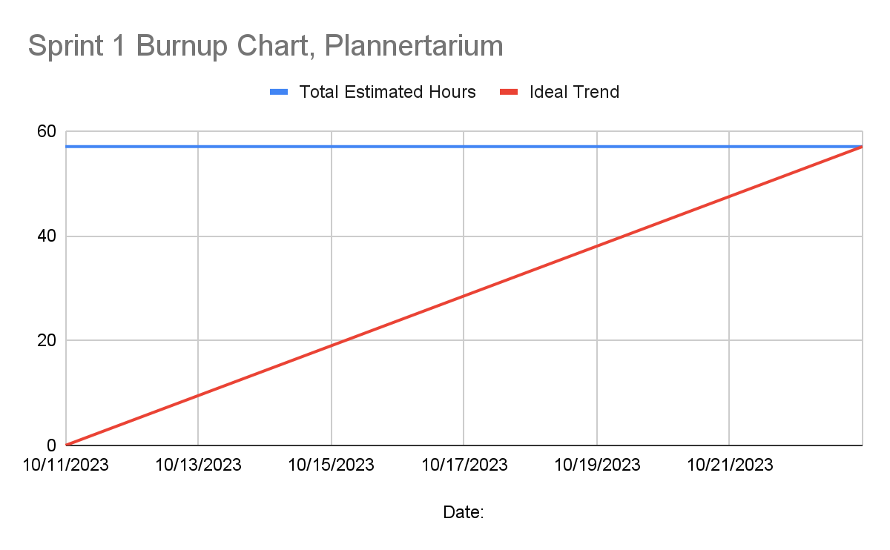](https://docs.google.com/spreadsheets/d/1SIR27Als7d3w4lPVdqzzbS3_kFWKfvY5UqsysHPZ46M/edit#gid=0)

# Initial Scrum Board

[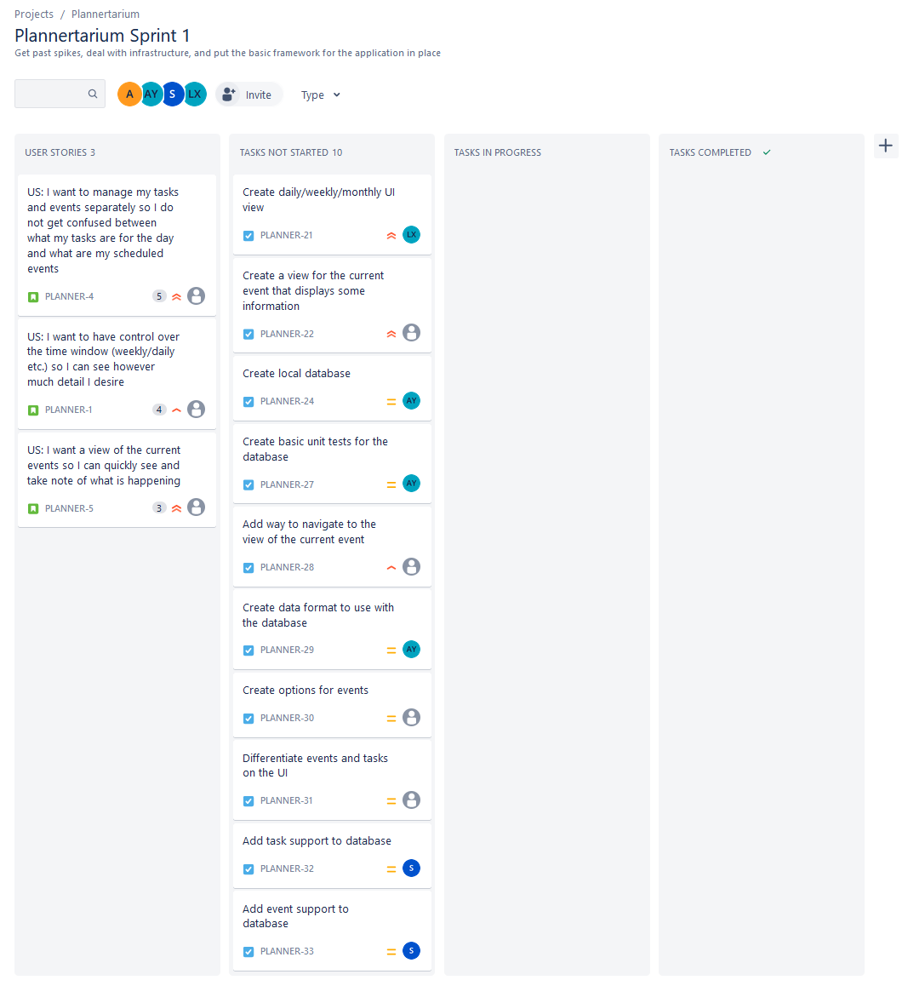](https://plannertarium.atlassian.net/jira/software/projects/PLANNER/boards/1)

# Scrum Times

Monday 12:15pm

Wednesday 6pm

Friday 6pm